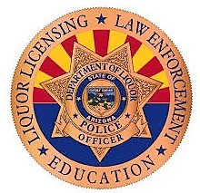
Arizona Liquor Law
Required Documents
Training
Reports
Guidance

Materials provided by
Arizona Liquor Industry Consultants
1811 S Alma School Rd. #268
Mesa, AZ 85210
(480) 730-2675

